**EU-LEX**

**Types of documents:**

* 1 Treaties
* 2 International agreements
* 3 Legislation
* 4 Complementary legislation
* 5 Preparatory acts
* 6 Case-law
* 7 National transposition measures
* 8 References to national case-law concerning EU law
* 9 Parliamentary questions
* 0 Consolidated acts
* C Other documents published in the Official Journal C series
* E EFTA documents

But on the website they can be found by:

* Regulation
* EU Court case
* Directive
* COM and JOIN documents
* Decision
* SEC or SWD document

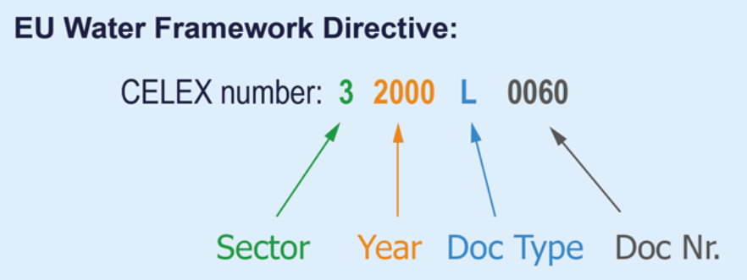

Sector: 0-9 and E and C

Doc Type or descriptor: A-Z, ME, country code or 2 letters to express a specific treaty…

**FOR Specific Sectors**

### **Treaties (sector 1)**

There are **3 digits** after the descriptor.

They indicate the **number of an article** of Treaty.

For example:

**11957E086** is the number for **Article 86** of the EEC treaty (1957).

#### **Consolidated versions of treaties**

These are indicated by **year of consolidation** , e.g.

**Treaty on the Functioning of the European Union** :

12016E – table of contents, consolidated version 2016

12016E/TXT – consolidated version 2016

12016E003 – Article 3, consolidated version 2016

### **International agreements (sector 2)**

These are identified by **publication date** .

So the international agreement No. **22006A1230(03)** was published in the *Official Journal* on 30 December 2006.

If several agreements are published on the same day, only the number in brackets changes: e.g. 22006A1230 **(01)**

### **Case-law (sector 6)**

Number is based on the **case number** issued by the Court of Justice.

The year is the **year** in which the case **entered the Court’s register** .

For example:

6 **2004** TJ0 **201**

This is the judgment in the **201st** case entered in the register in **2004** .

The **case number** is T-201/04.

### **Corrigenda**

Corrigenda have the *same number* as the document they are amending, with **R(xx)** added at the end (xx being the number of the corrigendum).

For example:

32009L0164R( **01** ) is the first corrigendum to **Directive 32009L0164** .

A corrigendum may relate to one or more language versions – or even all of them.

### **Consolidated acts (sector 0)**

Consolidated acts have the same number as the basic act – but its sector is **‘0’** instead of **‘3’** . For example: 02009L0156- **20161018**

**Citing outside the CELEX relm:**

For example, the ECLI of the **judgment** of the Court of Justice of 12 July 2005, *Schempp* (C‑403/03), is: ‘EU:C:2005:446’. [2](http://curia.europa.eu/jcms/jcms/P_126035/fr/#2)

This is broken down as follows:

* ‘EU’ indicates that it is a decision delivered by one of the Courts of the European Union (for decisions of national courts or tribunals, the code corresponding to the relevant Member State will appear instead of ‘EU’);
* **‘C’ indicates that this decision was delivered by the Court of Justice (decisions delivered by the General Court would be indicated by the letter ‘T’ and those of the Civil Service Tribunal by ‘F’**);
* ‘2005’ indicates that the decision was delivered in 2005;
* ‘446’ indicates that it is the 446th ECLI assigned in respect of the year in question.

**Judgement EU:C:2012:638**

Treaties: the Official Journal series and the issue and page numbers EX: OJ C306/01

Regulation, Directive and Decision: EX: Council Directive 2001/29/EC or (EC) 2001/29

**Regulation No 883/2004 or Regulation (EC) No 261/2004**

Official Journal:

(2018/C 063/15) or **C:2018:063:15**

* **L (legislation)**
* **C (information and notices)**

**References:**

* <http://eur-lex.europa.eu/content/tools/HowCelexNumbersAreComposed.pdf>
* <http://eur-lex.europa.eu/content/tools/TableOfSectors/types_of_documents_in_eurlex.html>
* <http://eur-lex.europa.eu/content/help/faq/celex-number.html>